Sieged.ml

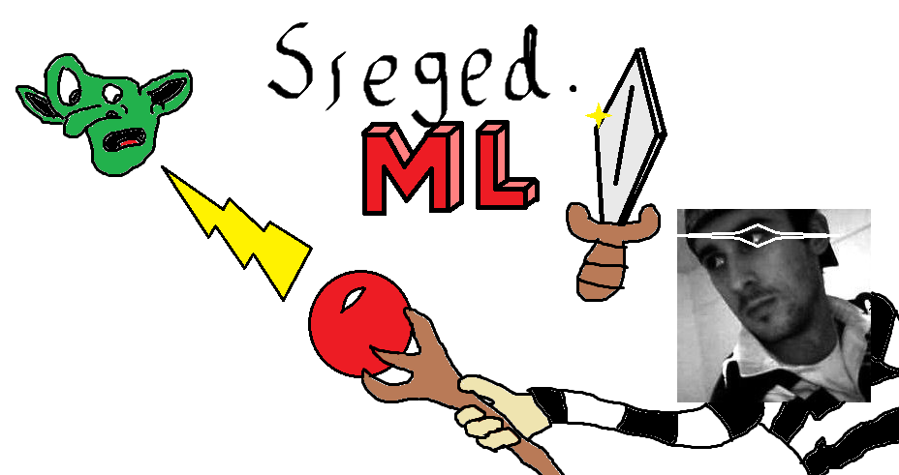

**Overview**

Four factions fighting for land, riches, and glory battle it out in Sieged.ml. This game is being made as a fun project that will show collaboration and skill with coding on a level not done in this class to date. Sieged is based off of a few simple .io games that everyone here has played before. One that we all enjoyed a lot had an interesting base building mechanic that we have expanded upon here with many more building types. That game also had a small faction/team system that could have up to three people working together, we have made this one of the main focuses of Sieged where you have the four factions working against each other to gain the most control and defeat the final boss. These four factions are Greek, Roman, Norse, and Egyptian. These were chosen because of their historical significance as well as for their history of wars and empires.

Sieged is made in unity and will be playable on pc and mac as long as they have an internet connection. Unity was chosen because of its easy interface and C# programming language. Unity also makes it easy to port games to other platforms.

**Common Questions**

**What is this?**

Sieged is a faction based game with PvP, PvE, and objective based gameplay. You control yourself with the keyboard, and attack with the mouse. You and the other members of your faction build a base and raise troops to fight the other factions and beat the boss to win. The faction that works together to defeat the other factions and the final boss is named victorious.

**Why make this?**

We made this game because we felt like the games that were out there were fun but could use some changes, so that’s what we did. We took ideas from a few different games that we had played and adapted and changed the mechanics until it became its own thing.

**What do I do as a player?**

As a player you will control your soldier, buy troops, build buildings, and earn gold and food to sustain yourself and your troops. You move around with wasd and attack things with the mouse, you can buy troops from a menu or with hotkeys, the buildings are also bought with hotkeys or a menu.

**Art**

**Color Schemes**

**Norse:**

**Blue**

|  |  |  |
| --- | --- | --- |
| **Tint** | **Color** | **Shade** |
| **#0035D4** | **#002FBD** | **#002BAB** |

**Greek:**

**Red**

|  |  |  |
| --- | --- | --- |
| **Tint** | **Color** | **Shade** |
| **#A10000** | **#900000** | **#800000** |

**Roman:**

**Purple**

|  |  |  |
| --- | --- | --- |
| **Tint** | **Color** | **Shade** |
| **#5500BB** | **#4E00AB** | **#440096** |

**Egyptian:**

**Yellow**

|  |  |  |
| --- | --- | --- |
| **Tint** | **Color** | **Shade** |
| **#E1C700** | **#BDA700** | **#A39000** |

**Features**

**General**

2D

Four factions

Base building

PvP

PvE

**Multiplayer**

Up to 20 players at once

Always available servers

**Marketing Information**

*Target Platform*: WebGL

*Target Audience*: children/young adults, those wishing to spend a few minutes at a time playing online with other gamers

*Target Rating*: N/A

*Target Genre:* Online Multiplayer Royale

*Market Competition*:

Agar.io

MooMoo.io

Lordz.io (major inspiration for the game)

**Object of The Game**

With a central raid boss taking up the center of the map, the four factions must

work with their teammates in order to level up and prepare for a fight with the

boss, incurring a win if they beat it or causing them to regain their levels and troops if they fail.

**Character System**

* Factions
  + Colors
    - Red (roman)
    - Green (greek)
    - Yellow (egyptian)
    - Blue (norse)
* Leveling
  + What Changes?
  + Builders
  + Skill trees
* Base building
* Map
  + Circle
  + Deadzone
    - Message will die if in for x amount of time
    - Countdown of five sec
* NPC interactions, simple AI
  + Mobs
    - Goblins (gold = 1, xp = 5)
      * Simple swing and run movement
    - Dwarves (gold = 5, xp = 20)
      * Simple swing and run movement
    - Soldiers (gold = 20, xp = 50)
      * Simple swing and run with occasional double strike with running movements
    - Archers (gold = 25, xp = 55)
      * Shoots arrow at player and runs
    - Mages (gold = 50, xp = 100)
      * Necromancer
        + Shoots a fast moving projectile that slows the player down. Travels with other mobs runs too.
      * Elemental
        + Shoots a ball of fire or earth at player and run mechanic.
    - Dragons (gold = 500, xp = 1000)
      * Can only be taken down by troops or players who have a ranged attack. Shoots fire beam for 3 seconds with a 2 second cooldown time.
  + Lowest average player, difficulty scales
  + Raid boss/objective in the center > 1 player
* Currency
  + Gold
    - Buildings, upgrades
  + Food
    - Units
* Population
  + Players: ~12 - 24 max
  + Troops:
    - Melee
      * Peasant
        + Low hp/ low dps
      * Swordsmen
        + Middle low hp/ moderate dps
      * Hoplite
        + Moderate hp/ middle high dps
      * Minotaur
        + High hp/ moderate damage

Pro

Very Very High hp

Con

Long and slow attack time

* + - Ranged
      * Javelin thrower
        + Same as peasants
      * Archer
        + Same as swordsmen
      * Ranger
        + Same as hoplite
      * Ballista
        + High hp/ high damage

Pro

Very Very high damage

Con

Cannot target players or mobs. Only buildings.

* + - AoE
      * Mage
        + Same as peasant
      * Wizard
        + Same as swordsmen
      * Sorcerer
        + Same as hoplite
      * Necromancer
        + High hp/ Low dps

Pro

Slows enemy

Con

Little to no damage to target

* Forced restart
* End game
  + Boss based on faction
* Leaderboard
  + Score
    - What does score take into account?
* Buildings
  + Farm - produces food-levels*5-max*10-gold*?
  + Mine - produces gold-levels*5-max*10-gold*?
  + Barracks - increases max population-levels*5-max*5-gold*?
  + Archer Tower - defence base levels*5
  + Tent - sets spawn point
  + Mage tower - How many purchased * PL

**CLASS: unit**

* cost
* bounty
* population
* hp
* damage
* threat

**CLASS: player**

* hp
* Gold
* Population
* Faction
* Speed

**CLASS: factions**

* Roman
* Greek
* Norse
* Egyptian

**CLASS: leaderboard**

* Coins = 1
* Troops = # of troops * level
* Building = cost * level of building
* Kills = 50 * PLK (player level killed)
* Skill = xp
* //Leaderboard / 10

**CLASS: controls**

* WASD (up, down, left, right)
* Hotkey troops and buildings (e.x. T = peasants and m = mages)
* Mouse (clicking, attacking)
* Tab (leaderboard and skills)
* m (map)?

|  |  |  |  |  |
| --- | --- | --- | --- | --- |
| Melee | Peasant | Swordsman | Hoplite | Minotaur |
| Ranged | Javelin | Archer | Ranger | Ballista |
| AOE | Mage | Wizard | Sorcerer | Necromancer |

Once we decide how fast/easy it is to gain gold we can start assigning values to things, these values will change as we balance the game. When we start having different running versions of the game we should make little change logs to record what features/balances/changes are made.

**CLASS: skills**

* Melee: mano y mano
  + Tank: High health/Low DPS (appears on everyone's mini map)
  + Stealth: Low Health/ High DPS (doesn’t appear on mini map)
* Ranged: attacks at a distance
  + Hunter: Moderate health/ Moderate DPS (ranged troops have further range)
  + Tracker: Moderate health/ low DPS (larger FoV, can see stealth, can see all players building)
* AoE: uses splash damage with spells
  + Sorcerer: Moderate Health/ Moderate DPS (high splash damage)
  + Shaman: High Health/ low DPS (creates a healing aura around player)

**Potential UI**

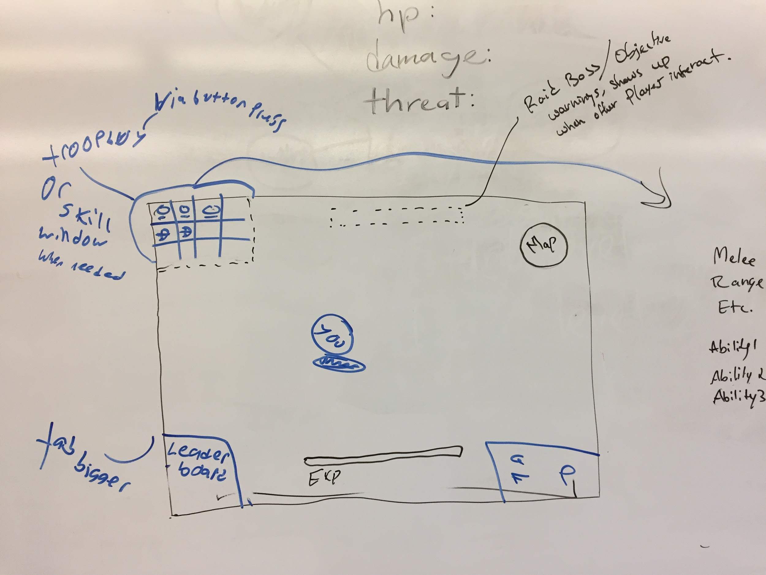

*Dropdown for unit buying menu*

